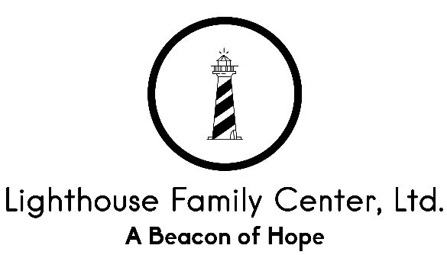

Authorization for Disclosure of Confidential Information and / or
Enrollment into the Multi-Agency Community Services
Information System (MACSIS)

To be eligible to receive public funds to help pay for the cost of your services, we must provide information to the Mental Health and Recovery Services Board of Stark County and / or to the Agency / Board in your county of residency.

The information must be provided in order to:

- Enroll you in your residing county’s plan.

- Determine what public funds can be used to pay for your services.

- Pay Lighthouse Family Center, Ltd through a system connected with the Ohio Department of Mental Health, Ohio Department of Alcohol & Drug Addiction Services, and the Ohio Department of Job and Family Services.

ALL INFORMATION COLLECTED WILL BE KEPT CONFIDENTIAL, consistent with State and Federal law. All uses for the information collected are described in Lighthouse Family Center, Ltd’s Privacy Practices Policy.

_____________________________________________ ________________________
Signature of Client or Parent / Legal Guardian Date

